WAN

**Research Area:** MAC in WiFi - 5G - 6G

**Participants:** Swati N Murty (MT2019120)

Sravya M (MT2019114)

**Topic:** Full Duplex (FD) Communications in Wireless Networks

Legacy:

In 802.11x, the base MAC protocol is CSMA/CA DCF, with virtual sensing using RTS/CTS protocols, using Half Duplex Communications (either of the transmitter or receiver have to be on at a time)

In 802.11ax and 5G, MIMO, OFDMA have been introduced to increase the spectral efficiency of the network. (<https://en.wikipedia.org/wiki/IEEE_802.11ax>).

What and why is FD?

Full Duplex communication means allowing AP and the station to simultaneously transmit and receive. (by Self Interference cancellation techniques at PHY layer)

By this, the channel capacity/ spectral efficiency can be doubled.

If a station can transmit and receive at the same time, if it can sense any other signal while transmission, it need not wait for a long collision duration, it can stop transmission at the same instance.

Modes of Operation/ types of wireless links:

As this method should have backend compatibility with legacy systems, we may have 3 different types of links between stations. (Assuming Infrastructure mode)

1. BFD (Bidirectional Full Duplex Transmission) with 2 nodes:

FD capable AP and STA pair can simultaneously transmit and receive from each other.

1. UFD (Unidirectional Full Duplex Transmission) with 3 nodes:

FD capable AP can simultaneously transmit to a HD station and receive from another HD station. Both the stations have to be out of interference range.

1. UFD-1: Station A wins the contention through RTS and transmits to AP, AP starts transmitting another station B as it does not have data to send to A.
2. UFD-2: AP starts transmitting to Station A, and another station B having data to AP transmits to AP.

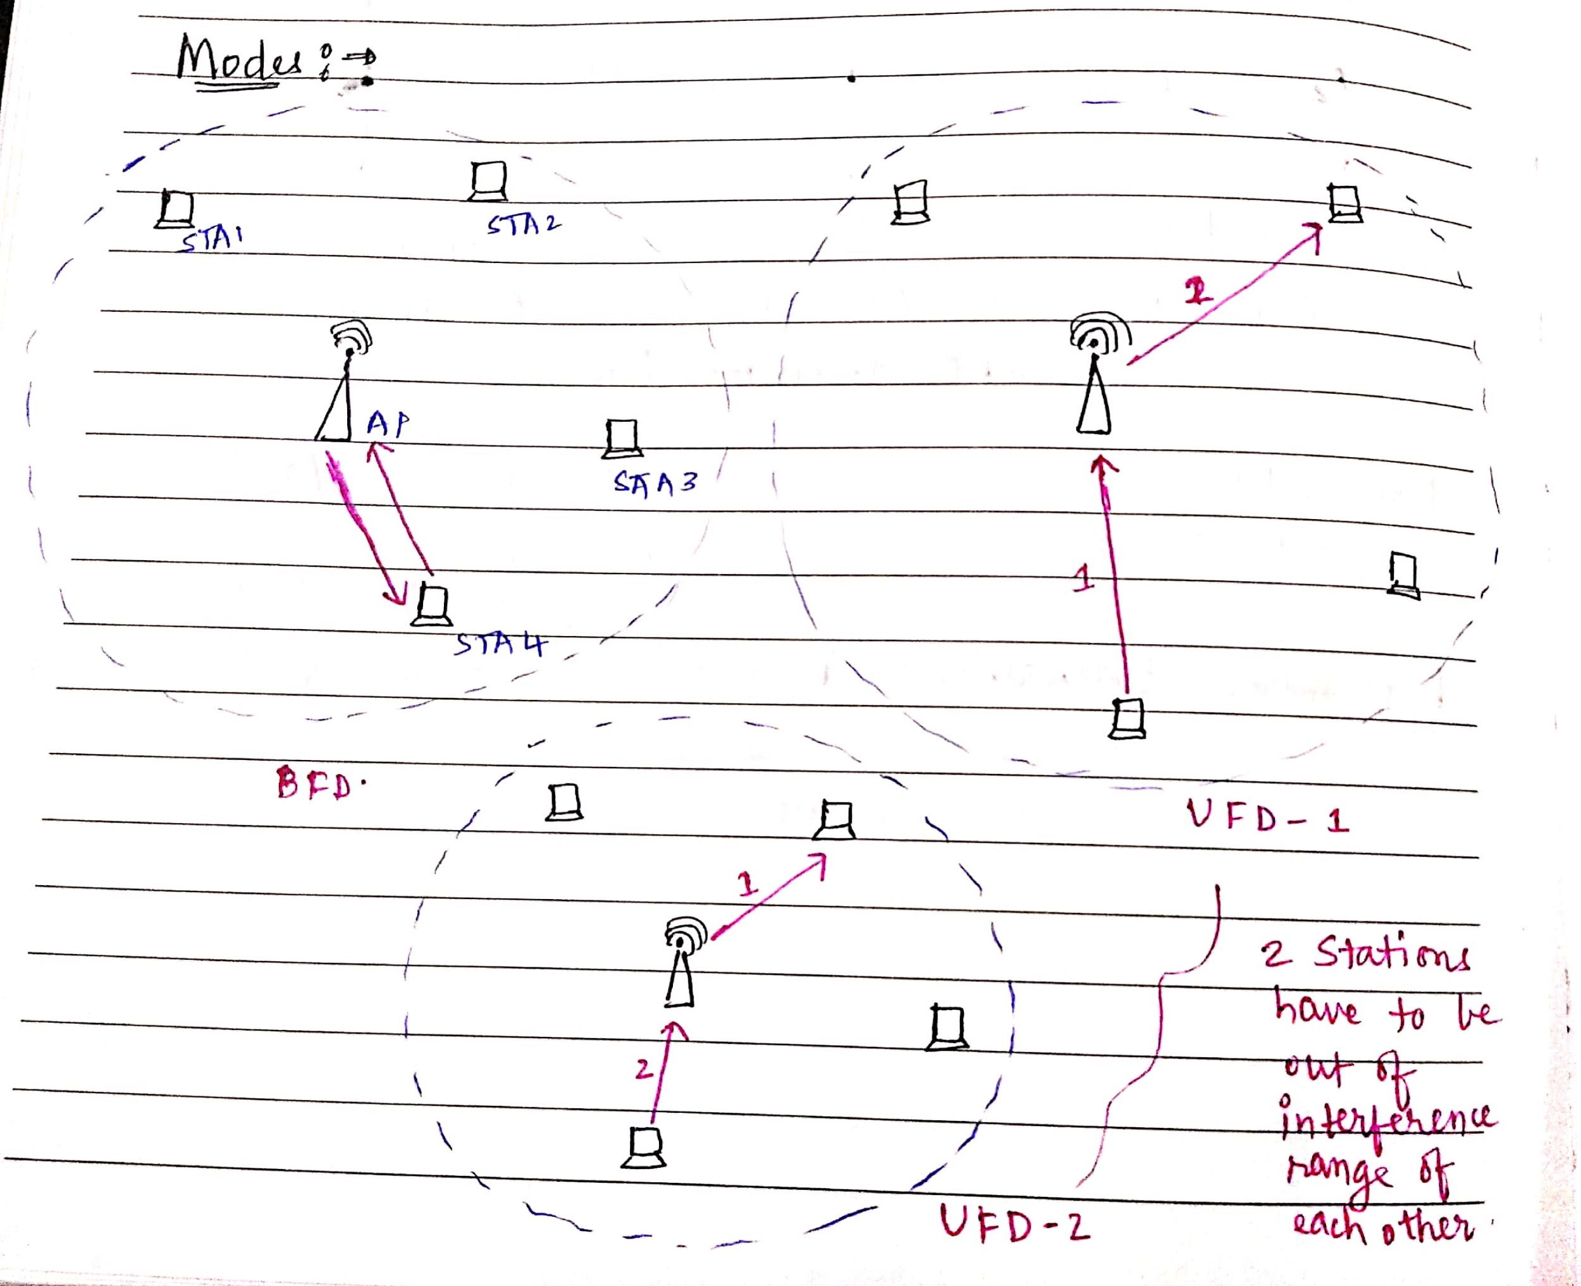

Physical Layer Protocols:

1. **Passive Suppression:**

This is achieved by physically separating the transmit and receive antennas(TAs and RAs). There are 3 techniques in this method:

1. *Antenna Separation (AS)-Based Passive Suppression:*

TAs and RAs are attached to opposite ends of the device. Practically not feasible with devices getting smaller everyday.

1. *Antenna Cancellation (AC)-Based Passive Suppression:*

Here 2 TAs and 1 RA is used. TAs are placed at distances d and (d+ wavelength/2) distance away from RA. The RA is positioned at an odd multiple of wavelength/2, which results in signals cancelling each other after being superimposed destructively.

1. *Directional Passive Suppression:*

Main radiation lobes of TA and RA of an FD node have minimal intersection.

1. **Analog Self Interference Cancellation**

In order to sufficiently reduce the SI power, an FD radio is required for creating a reference signal corresponding to a perfect replica of the SI signal at all instances. Combining this replica and the SI signals is in theory capable of facilitating perfect SI cancellation

1. **Digital Self Interference Cancellation**

Digital cancellation constitutes an active SI-mitigation mechanism that by definition operates in the digital do- main and exploits the knowledge of the interfering signal in order to cancel it after the received signal has been quantized by the ADC.

MAC Protocols:

1. **Busy-Tone Aided MAC protocol:**

Mainly for avoiding Hidden Terminal Problem.

Whenever a node completes transmission before its paired device, it has to send a predefined busy tone.

If the secondary node doesn’t have any data to send, it has to start a busy tone immediately after receiving the header from the primary node.

Not suitable for high data speed networks.

1. **FD-MAC protocols:**

These protocols have been formed based on the modes of FD transmissions possible.

The modes of transmission by nodes will be communicated through an extra field FD_MODE in RTS, CTS.

Ex: 00 - HD, 01 - BFD, 10 - UFD-1, 11 - UFD -2.

As discussed above, there can be 3 modes. (FD, UFD-1, UFD-2)

1. **Shared Random Backoff:**

This protocol is for BFD transmission mode. In BFD transmission, after sending a packet data the nodes have to stop for letting other nodes to transmit. Again while their turn comes, it may be possible that they may have different backoff count which leads to asynchronous transmissions. To avoid this, both the nodes will communicate a fixed random backoff and start retransmitting at the same time.

1. **Snooping:**

Header Snooping protocol is useful in UFD-2 mode. When AP transmits to station A, a node B in the network which has data for AP will observe that the channel is busy and it will not send.

With header snooping, every other node will hear the RTS which initiates with FD_MODE as 01, but if the station A replies with FD_MODE as 00, the station B will listen to this and can start transmitting to AP.

1. **Virtual Contention:**

This protocol needs a scheduling mechanism in the Transmission Buffer of a node, which enables it to transmit a packet which is behind the buffer first to utilise the FD modes and increase the throughput.

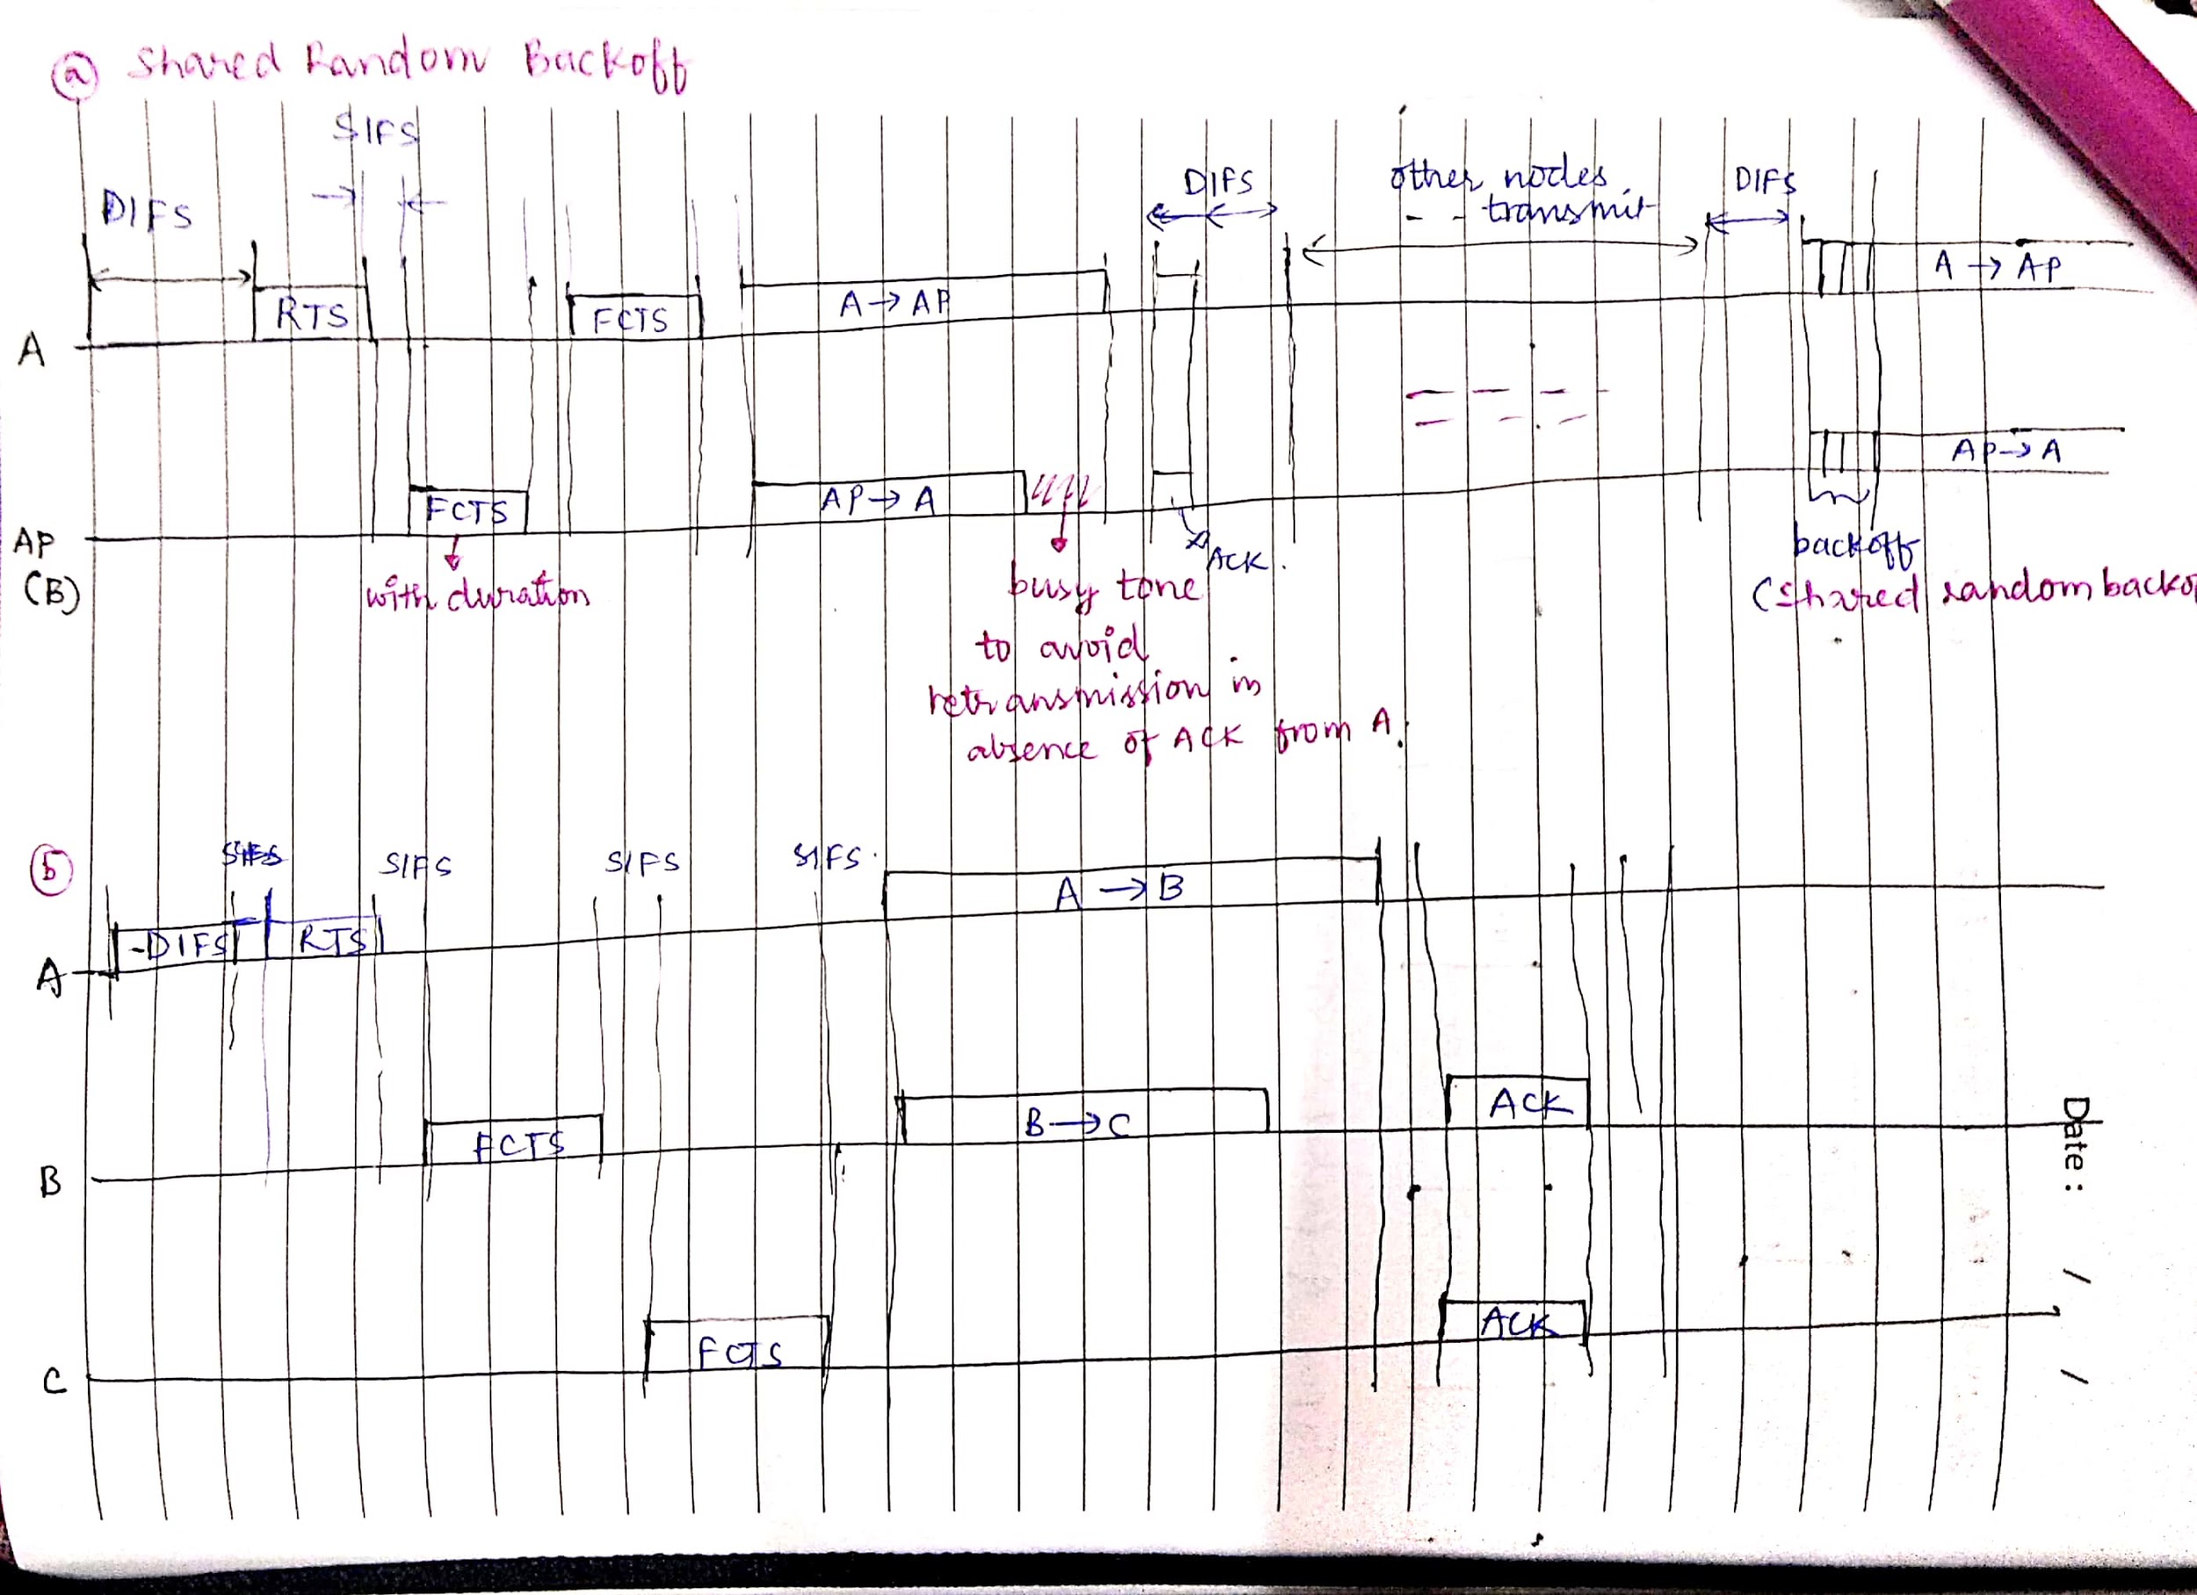

Issues in Design/ Potential Problems:

1. AP has to be FD capable, and finding FD/ HD capable nodes is difficult.
2. Node selection in UFD: As the 2 stations have to be out of the interference region of each other, it will be difficult to find such nodes for AP.
3. Scheduling the buffer in Virtual Contention: Delaying the HOL packets is not feasible.
4. **Header snooping:** what if multiple stations have data to AP, there is a lot of scope for collision.